Introduction

The purpose of this report is to accompany a software project and the explain in greater detail the reasoning behind the design of the game. As well as this the report aims to elaborate on the problems encountered during the creation of the software project and how they were solved. The project was written purely in C++ with Windows and DirectX libraries, with Visual Studio the compiler of choice. The project makes use of the ObjFileModel class and 2DText class that are provided within the Southampton Solent University tutorials to load .obj files and create basic 2d rendered text respectively.

Implementation

The game being created for this assignment was one based off of the design documentation created previously in AE1. Using these documents I created a version of the original game but with a class structure and hierarchy that I was more comfortable working on. As a result the end product differs enough from the design that it required some reworking on class structures.

While changing the designs I found that a few of the class diagrams and flow charts were either redundant, or in the case of scene management could be merged into multiple classes. For the actual implementation I used Microsoft's own documentation on DirectX to better understand the structures and function calls that I used during the creation of the project.[1] As well as this I also used the tutorials provided by Southampton Solent University to aid with the understanding of key DirectX features and initialisation of the system itself.

Throughout the project I encountered numerous problems of varying degrees of severity. Some were minor mathematical errors such as learning how the Plane Equation is used to provide more complex collision detection, while others were more complex to the point that I was unable to successfully implement them into the program without causing massive errors. One such problem was the Phong Reflection Model and how the shader mathematics worked to allow the light to effect the model in the correct order.[2] The theory of this method of lighting a model is that there are five vectors that point outward from a model that allow it to have a reflective light effect wherever the camera is pointed at it.

The vectors N (Normal), L(Light), R(Reflected), V(View), and H(Half) are used in the equation below to return I, which is the shading value of each point on the surface. k represents the coefficient of the ambient, diffuse and specular while i represents the intensity.

Phong equation

The below is the mathematical Plane equation that allows us to take in points, multiply by the normal of a play and add the offset of the plane. This returns a float that is then used to determine if the point is inside a triangle or not. This is implemented within the project to allow for ray cast collision, that lets the system detect pixel perfect collisions.

(x_{n} * x) + (y_{n} * y) + (z_{n} * z) + d = 0

Plane equation example

Testing

While testing the collision code for any bugs I encountered an issue during the initialisation stages of my graphics cod. The image below shows the values within the model class that calculate the centre point of the model which will then be used to collect the radius of the model for basic collision. However the code below shows the member m_bounding_sphere_radius to equal the value of distance but for some reason the centre_y instead is given the value of distance.

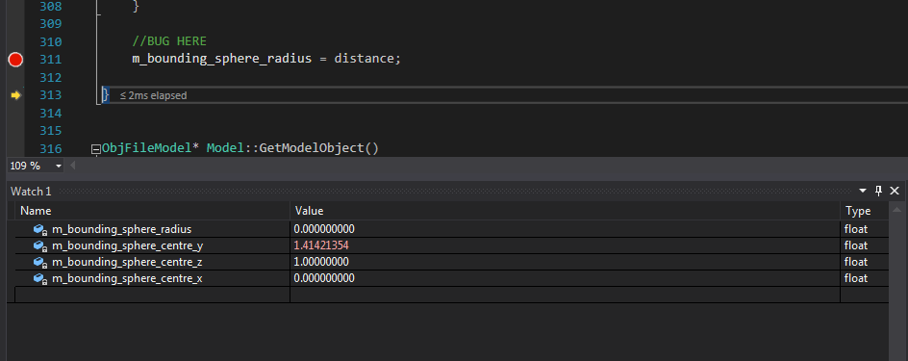
This bug was discovered when the enemy follow code would get stuck on what seems like nothing. On further inspection I found that the radius of the two objects were now behaving properly, causing certain checks to be skipped as the system believed that a collision had occurred.

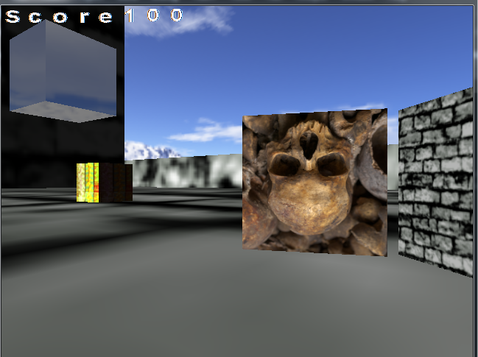

Conclusion

In closing I believe that the overall project went well and proceeded without any major hindrances, although I would spend more time on learning the various DirectX methods as a large amount of problems I did encounter were due to unfamiliarity with the API. I would also spend more time understanding the collision mathematics as that was an area that I struggled on the most, losing whole work days attempting to solve problems that were small in the overall scope.

One improvement to the project that could be achieved is to optimise the classes that make up the project. The reason for this is that a lot of the classes either reuse code or contain the same pointers to DirectX structures, creating more loss of memory through the creation and deletion of pointers. My opinion for the cause of this is that a lack of understanding in how DirectX works, for example the DeviceContext is used to actively change and fill out information for the main D3DDevice. Ideally only one instance of this would exist to allow for optimal performance and to avoid needless pointers to pointers.

A problem that was realised once production had started was that the original design documents were fairly unusable as a lot of the flow charts did not make sense in relation to how Windows handles messages. As a result and to not waste the original design I made the decision to use them as a guide towards how the main game loop and class should loop and loop within itself, all while allowing for Windows to handle the window and message loop without causing any problems.

Lastly the original game design and systems were too ambitious considering the amount of time and lack of knowledge of DirectX. This was caused by a personal assumption that DirectX would be similar in many ways to both SDL and the Playstation 4 SDK which I have had experience in prior to this project.

References

https://msdn.microsoft.com/en-us/library/windows/desktop/ee663274(v=vs.85).aspx

